Міністерство освіти та науки України
ДВНЗ «Приазовській державний технічний університет»
Кафедра інформатики

Звіт з Лабораторної роботи№ 1
З дисципліни «Теорія та практика мов програмування»
Тема: «Теорія та практика мов програмування»

Виконав
Студент групи KH23
Колесніченко Кирило Олександрович

Перевірила
Проніна О.І.

Дніпро, 2024

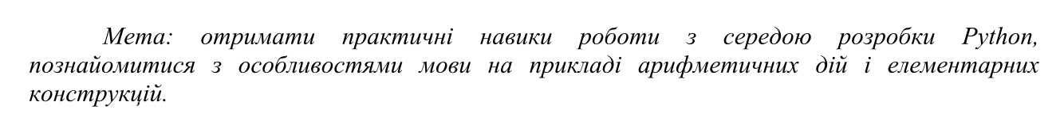

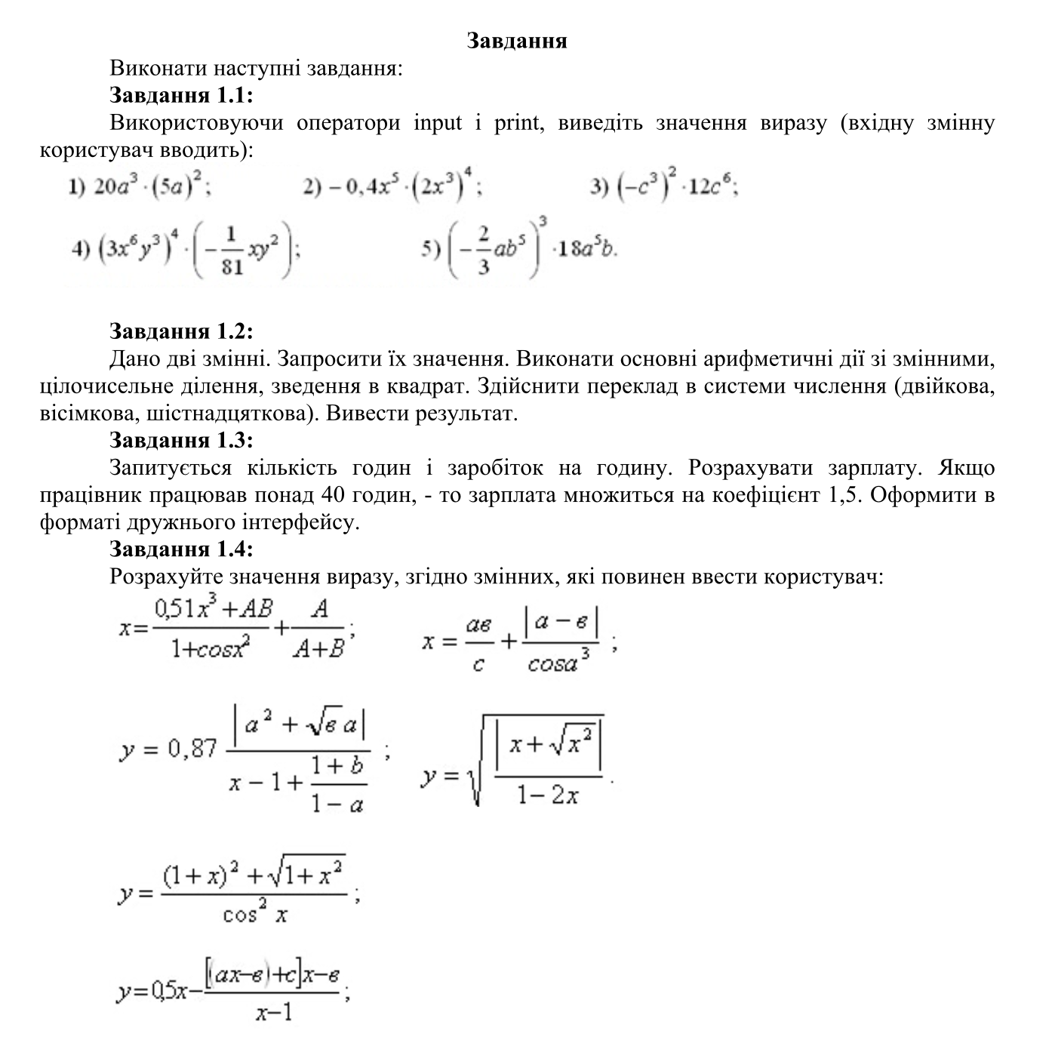

Код

Task_1

- def task_1():
choice = int(input("Choose an option: "
"1. 20a^3*(5a)^2\n"
"2. -0,4x^5*(2x^3)^4\n"
"3. (-3c^3)^2*12c^6\n"
"4. (3x^6y^3)^4*(-(1/81)*xy^2)\n"
"5. (-(2/3)ab^5)^3*18a^5b\n\n"
"Enter your choice: "))
if not 1 <= choice <= 5:
exit("invalid choice")
if choice == 1:
a = float(input("Enter the value of a: "))
result = 20 * a ** 3 * (5 * a) ** 2
print(f"The result is {result}")
elif choice == 2:
x = float(input("Enter the value of x: "))
result = -0.4 * x ** 5 * (2 * x ** 3) ** 4
print(f"The result is {result}")
elif choice == 3:
c = float(input("Enter the value of c: "))
result = (-3 * c ** 3) ** 2 * 12 * c ** 6
print(f"The result is {result}")
elif choice == 4:
x = float(input("Enter the value of x: "))
y = float(input("Enter the value of y: "))
result = (3 * x ** 6 * y ** 3) ** 4 * (-(1 / 81) * x * y ** 2)
print(f"The result is {result}")
elif choice == 5:
a = float(input("Enter the value of a: "))
b = float(input("Enter the value of b: "))
result = (-(2 / 3) * a * b ** 5) ** 3 * 18 * a ** 5 * b
print(f"The result is {result}")
task_1()

Task_2
- variable_1 = int(input("Enter the first variable: "))
variable_2 = int(input("Enter the second variable: "))
print(variable_1, "+", variable_2, "=", variable_1 + variable_2)
print(variable_1, "/", variable_2, "=", variable_1 / variable_2)
print(variable_1, "and", variable_2, "in binary:", bin(variable_1)[2:], "and", bin(variable_2)[2:])
print(variable_1, "and", variable_2, "in hexadecimal:", hex(variable_1)[2:], "and", hex(variable_2)[2:])
print(variable_1, "and", variable_2, "in octal:", oct(variable_1)[2:], "and", oct(variable_2)[2:])

Task_3
- working_hours = float(input("Enter your working hours: "))
wage = float(input("Enter your wage: "))
if working_hours > 40:
overtime_hours = working_hours - 40
salary = (40 * wage) + (overtime_hours * wage * 1.5)
else:
salary = working_hours * wage
print(f"Total salary: {salary:.2f}")

Task_4
- import math
choice = int(input("Choose an option:\n"
"1.x=(0.51x^3+AB)/(1+cos^2(x))+A/(A+B)\n"
"2.x=(ae/c)+|(a-e)/cos(a)^3|\n"
"3.y=0.87*|a^2+sqrt(e)*a|/(x-1+(1+b)/(1-a))\n"
"4.y=sqrt(|x+sqrt(x^2)|/(1-2x))\n"
"5.y=((1+x)^2+sqrt(1+x^2))/cos^2(x)\n"
"6.y=0.5x-[(ax-e)+c](x-e)/(x-1)\n\n"
"Enter your choice: "))
if not 1 <= choice <= 6:
exit("Invalid choice")
if choice == 1:
A = float(input("Enter the value of A: "))
B = float(input("Enter the value of B: "))
x = float(input("Enter the value of x: "))
result = (0.51 * x ** 3 + A * B) / (1 + math.cos(x) ** 2) + (A / (A + B))
print(f"The result is {result}")
elif choice == 2:
a = float(input("Enter the value of a: "))
e = float(input("Enter the value of e: "))
c = float(input("Enter the value of c: "))
result = (a * e / c) + abs((a - e) / (math.cos(a) ** 3))
print(f"The result is {result}")
elif choice == 3:
a = float(input("Enter the value of a: "))
b = float(input("Enter the value of b: "))
e = float(input("Enter the value of e: "))
x = float(input("Enter the value of x: "))
numerator = abs(a ** 2 + math.sqrt(e) * a)
denominator = x - 1 + (1 + b) / (1 - a)
result = 0.87 * (numerator / denominator)
print(f"The result is {result}")
elif choice == 4:
x = float(input("Enter the value of x: "))
result = math.sqrt(abs(x + math.sqrt(x ** 2)) / (1 - 2 * x))
print(f"The result is {result}")
elif choice == 5:
x = float(input("Enter the value of x: "))
numerator = (1 + x) ** 2 + math.sqrt(1 + x ** 2)
denominator = math.cos(x) ** 2
result = numerator / denominator
print(f"The result is {result}")
elif choice == 6:
a = float(input("Enter the value of a: "))
e = float(input("Enter the value of e: "))
c = float(input("Enter the value of c: "))
x = float(input("Enter the value of x: "))
numerator = ((a * x - e) + c) * (x - e)
result = 0.5 * x - (numerator / (x - 1))
print(f"The result is {result}")

